
MINI PROJECT REPORT

PROJECT NAME : QUIZ APP

SUBMITTED BY ,
NAME : SABARISH S
REGISTER NUMBER : 922525243187
DEPARTMENT : B.TECH AI&DS
ACADEMIC YEAR : 2026-2027
YEAR / SEMESTER : 2ND YEAR /ODD SEMESTER

INTRODUCTION
The Nova Smart Quiz App is a web-based platform designed to simplify quiz creation, management, and evaluation for teachers and students. The application allows teachers to create quizzes manually or through bulk question imports, while students can attend quizzes online and receive instant results. The system improves assessment efficiency, reduces manual work, and provides detailed performance analytics.

KEY FEATURES

User-friendly teacher and student interfaces

Quiz creation using manual entry or bulk upload

Multiple question types (MCQ, checkbox, short answer, text response)

Automatic evaluation and score calculation

Real-time result generation

Student performance tracking

Quiz status management (Active/Inactive)

Responsive design for mobile and desktop devices

Secure login and authentication

MODULES
1. User Authentication Module
- Teacher and student login
- Secure account management
2. Quiz Management Module
- Create, edit, delete quizzes
- Manage quiz availability
3. Question Management Module
- Add questions manually
- Bulk import questions
4. Student Assessment Module
- Attend quizzes online
- Submit answers
5. Result Processing Module
- Automatic scoring
- Result generation
6. Analytics Dashboard Module
- View student scores
- Track quiz performance

SYSTEM ARCHITECTURE
Teacher → Quiz Creation → Database → Quiz Publishing → Student Attempt → Evaluation Engine → Results Dashboard
Architecture Flow
- Teacher logs in.
- Teacher creates quizzes and questions.
- Data is stored in the database.
- Students access available quizzes.
- Students submit responses.
- System evaluates answers automatically.
- Results and analytics are displayed.

IMPLEMENTATION (CODING)
Sample HTML
<h1>Nova Smart Quiz App</h1>
<button>Start Quiz</button>
Sample JavaScript
function calculateScore(correct, total){
return (correct / total) * 100;}
Sample Python
score = (correct_answers / total_questions) * 100
print("Score:", score)

OUTPUT SCREENSHOTS

1.Login Page



2. Teacher Dashboard

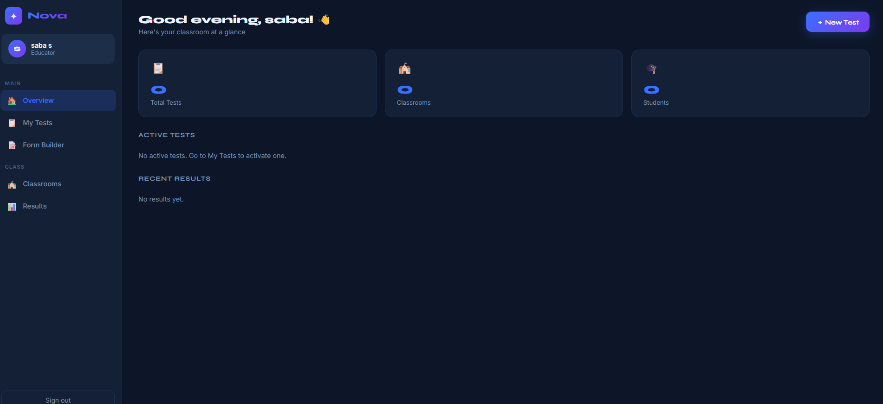

3.Quiz Builder

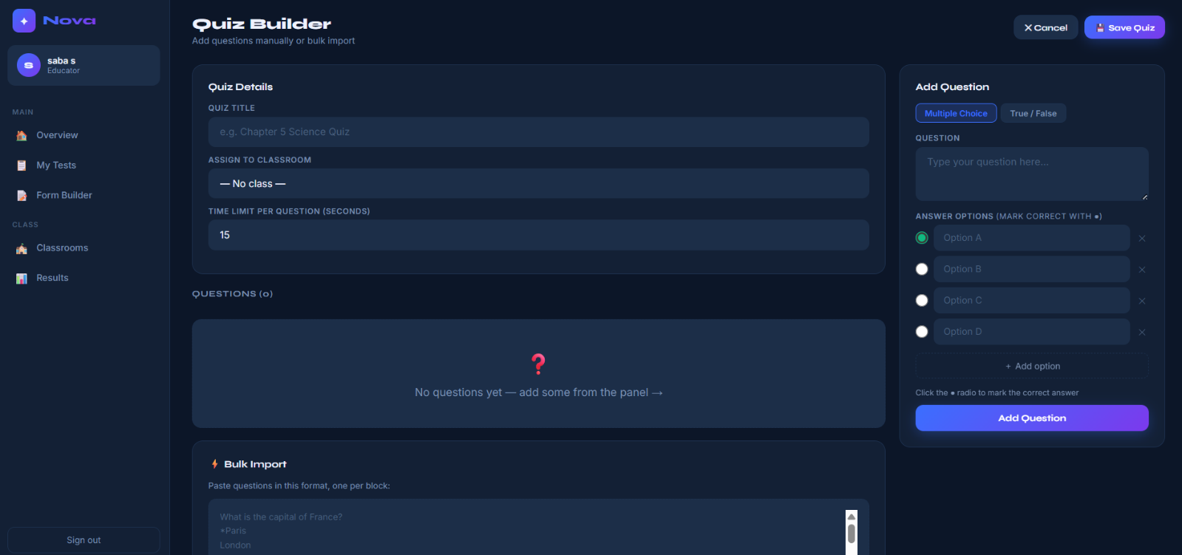

4. Student Quiz Page



ER DIAGRAMS

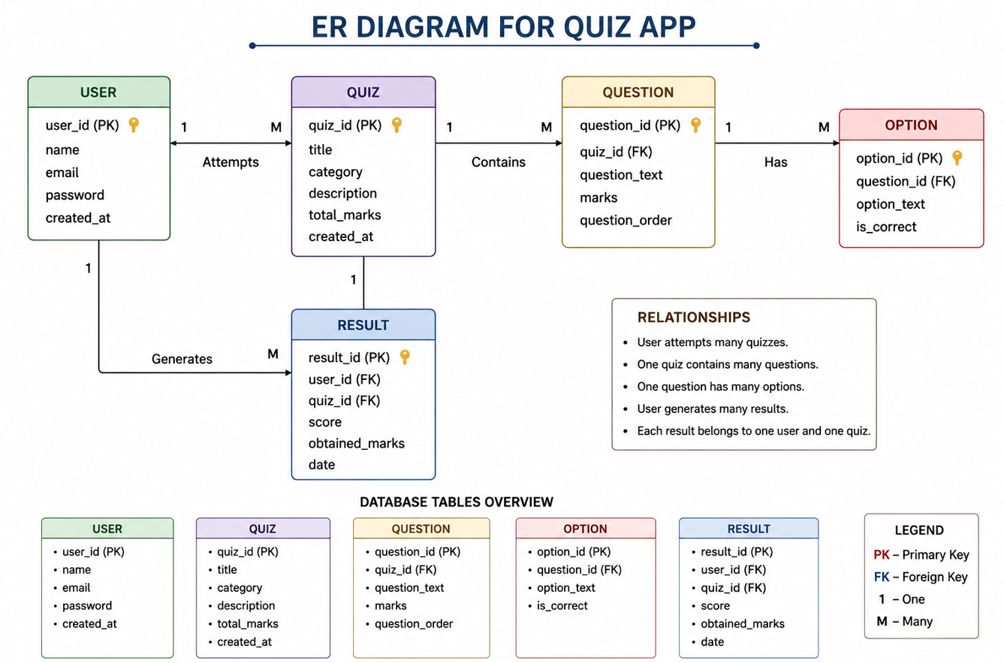

SOFTWARES USED

Visual Studio Code

GitHub

Google Chrome

Node.js

MySQL

TECHNOLOGY STACK

Frontend

HTML

CSS

JavaScript

Backend

Node.js

Express.js

Database

MySQL

Version Control

GitHub

ADVANTAGES AND DISADVANTAGES

Advantages:

Easy quiz creation

Instant evaluation

Reduced paperwork

Better student tracking

Accessible anywhere

Disadvantages:

Requires internet connection

Depends on device availability

Initial setup required

CONCLUSION

The Nova Smart Quiz App provides a smart and efficient solution for conducting online assessments. It helps teachers manage quizzes easily while enabling students to participate and receive instant feedback. The system improves educational assessment through automation, accuracy, and ease of use.

REFERENCES

HTML Documentation

CSS Documentation

JavaScript Documentation

Node.js Documentation

MySQL Documentation

GitHub Documentation

PROJECT/GITHUB LINK:

https://github.com/saba220308/QuizNova

THANK YOU..!

